**Select**

The SELECT statement is used to select data from a database. The result is stored in a result table, called the result-set.

SELECT * FROM table_name;

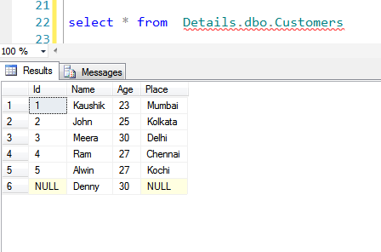

SELECT column_name,column_name  
FROM table_name;

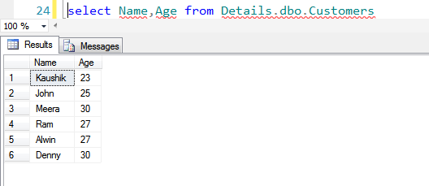

The SELECT DISTINCT statement is used to return only distinct (different) values.

In a table, a column may contain many duplicate values; and sometimes you only want to list the different (distinct) values. The DISTINCT keyword can be used to return only distinct (different) values.

SELECT DISTINCT column_name,column_name  
FROM table_name;

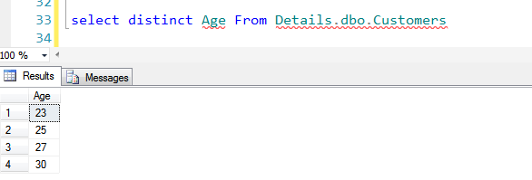

The WHERE clause is used to filter records. The WHERE clause is used to extract only those records that fulfill a specified criterion.

SELECT column_name,column_name  
FROM table_name  
WHERE condition

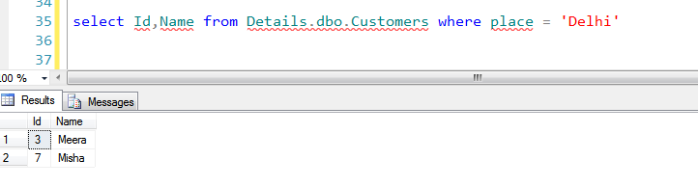

SELECT statements with ORDER BY clauses to show how data can be sorted in both ascending and descending.

SELECT column_name,column_name  
FROM table_name  
ORDER BY column_name ASC

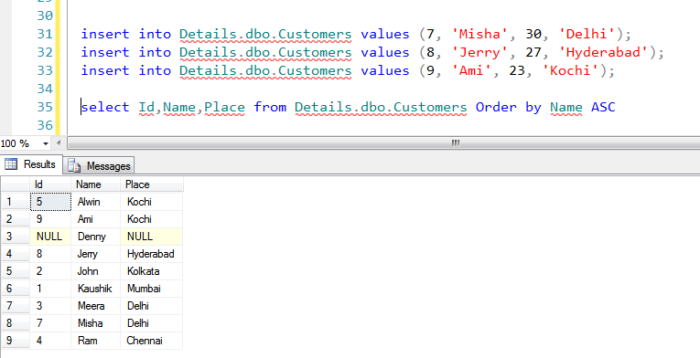

SELECT column_name,column_name  
FROM table_name  
ORDER BY column_name DESC

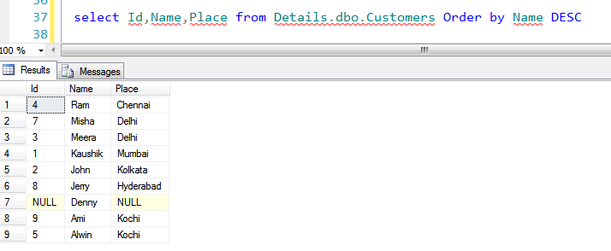

SELECT column_name,column_name  
FROM table_name  
ORDER BY column_name DESC,column_name ASC

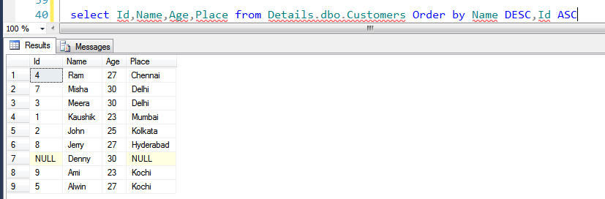

The **ORDER BY** clause’s purpose is to sort the query result by specific columns. The **GROUP BY** clause’s purpose is summarizing unique combinations of columns values. GROUP BY will aggregate records by the specified columns which allows you to perform aggregation functions on non-grouped columns

SELECT column_name,column_name  
FROM table_name  
GROUP BY column_name,column_name ORDER BY column_name

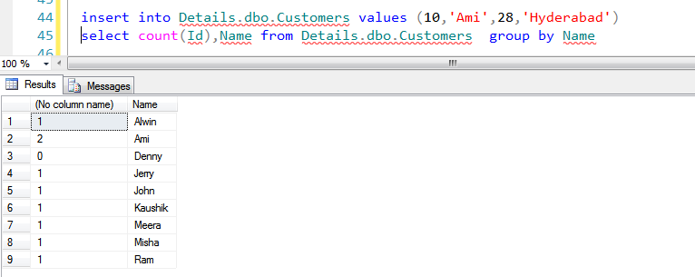

The AND & OR operators are used to filter records based on more than one condition. The AND operator displays a record if both the first condition AND the second condition are true.

The OR operator displays a record if either the first condition OR the second condition is true.

**AND**

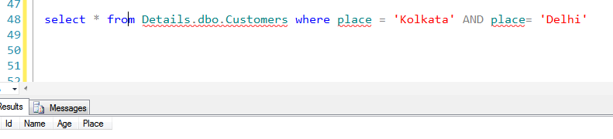

**OR**

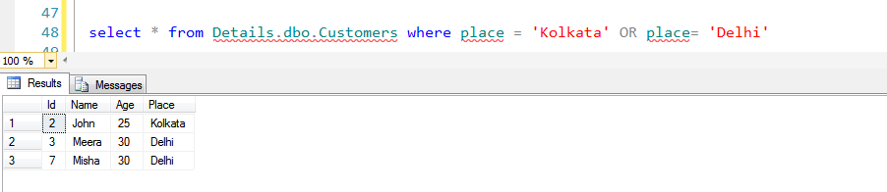

**TOP**

The SELECT TOP clause is used to specify the number of records to return.

The SELECT TOP clause can be very useful on large tables with thousands of records. Returning a large number of records can impact on performance.

SELECT TOP *number*|*percent* *column_name(s)*  
FROM *table_name*;

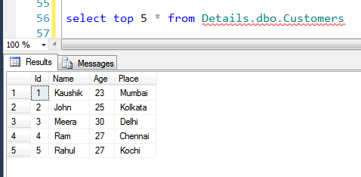

**IN**

The IN operator allows you to specify multiple values in a WHERE clause.

SELECT column_name(s)  
FROM table_name  
WHERE column_name IN (value1,value2,...);

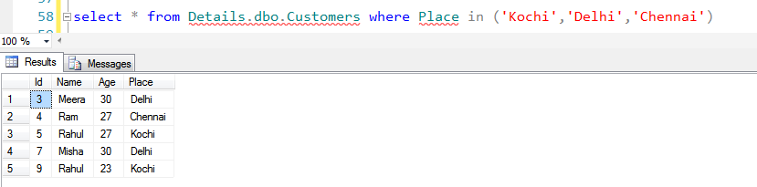

**BETWEEN**

The BETWEEN operator selects values within a range. The values can be numbers, text, or dates.

SELECT column_name(s)  
FROM table_name  
WHERE column_nameBETWEEN value1 AND value2

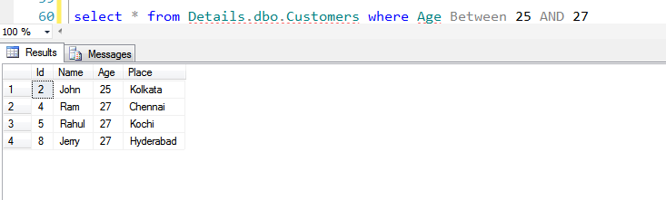

**WILDCARDS**

A wildcard character can be used to substitute for any other character(s) in a string.

% - A substitute for zero or more characters.

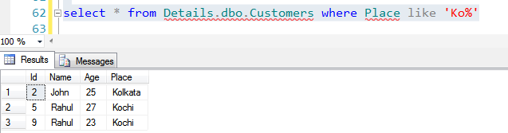

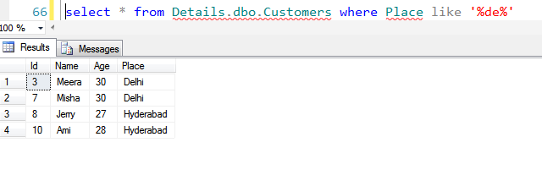

_ - A substitute for single character.

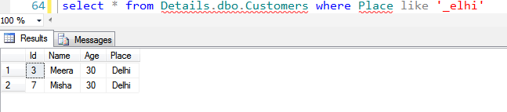

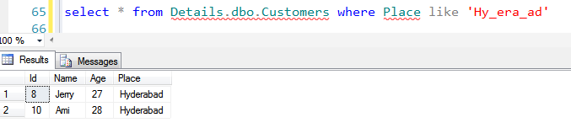

[charlist]

To display the words starting with K,C and M.

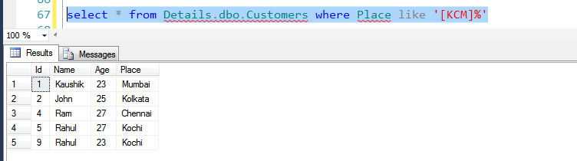

To display all words starting with in between C and K.

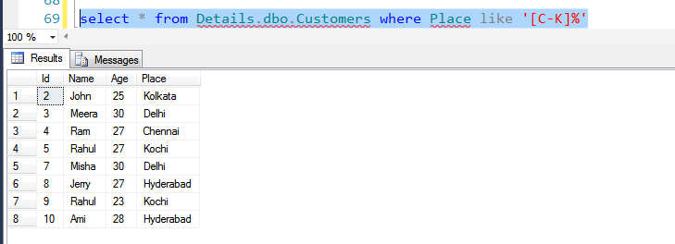

Not Like

